Part 1: Search for an online encoding and decoding tool.

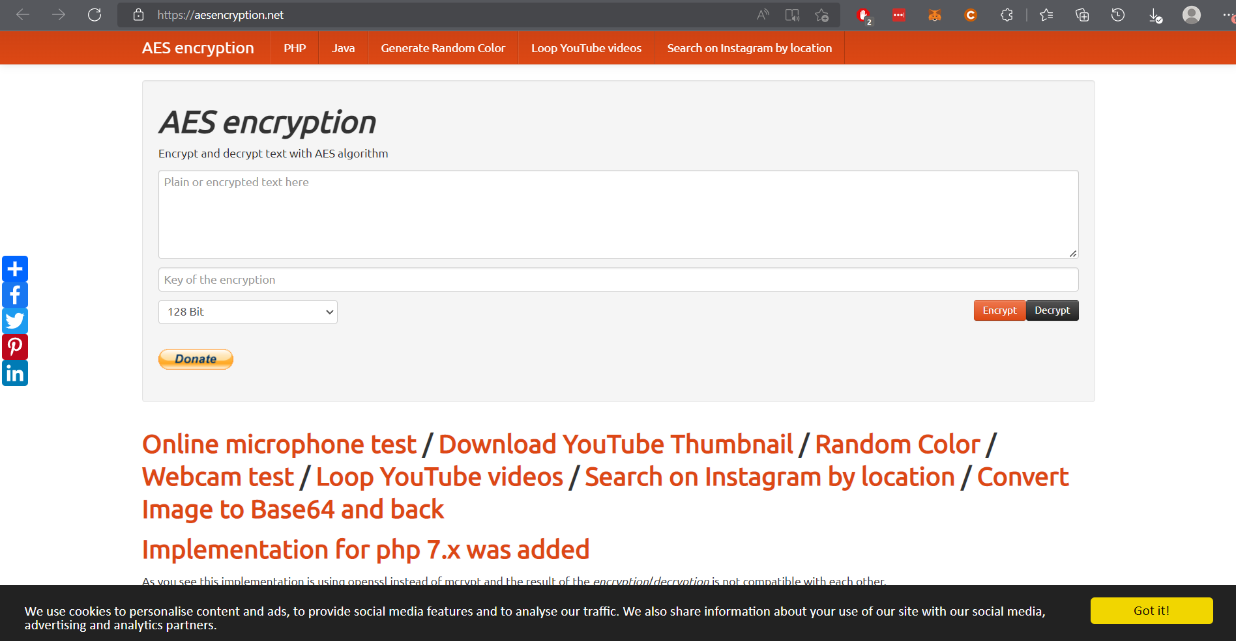

Part 2: Encrypt a message and email it to your lab partner.

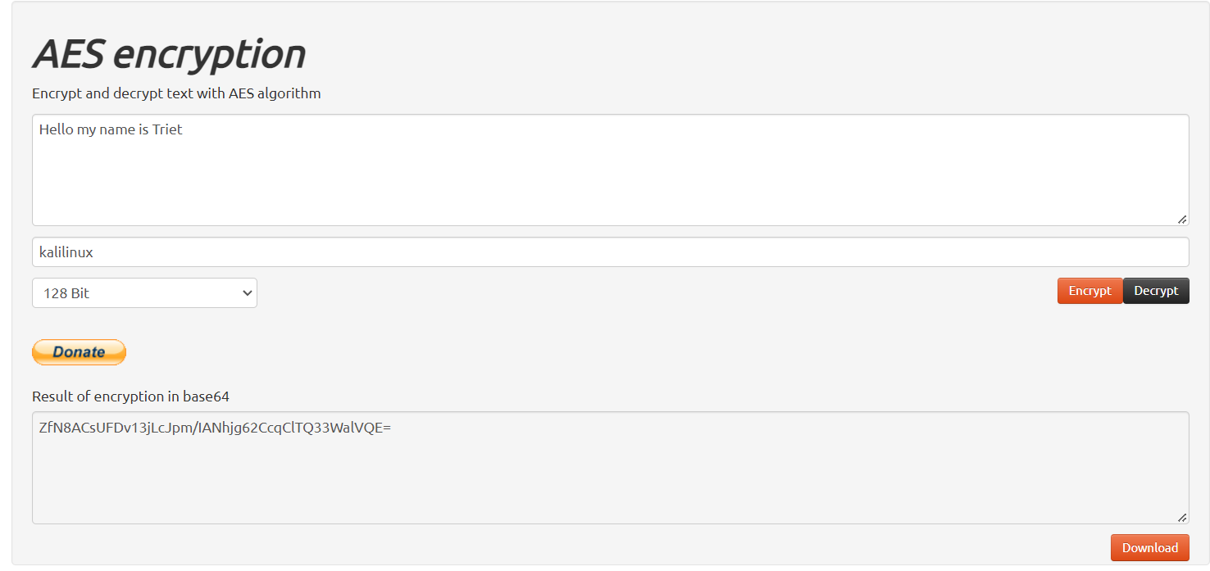

Part 3: Decrypt the ciphertext.

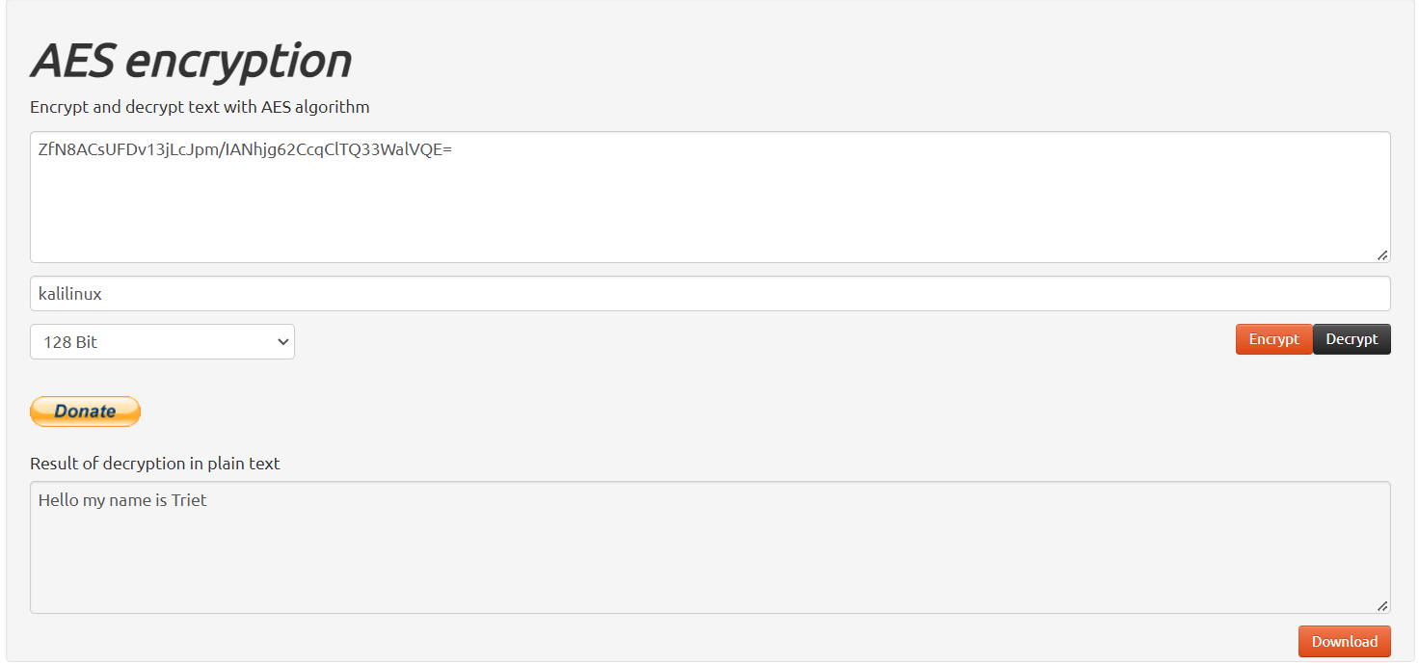

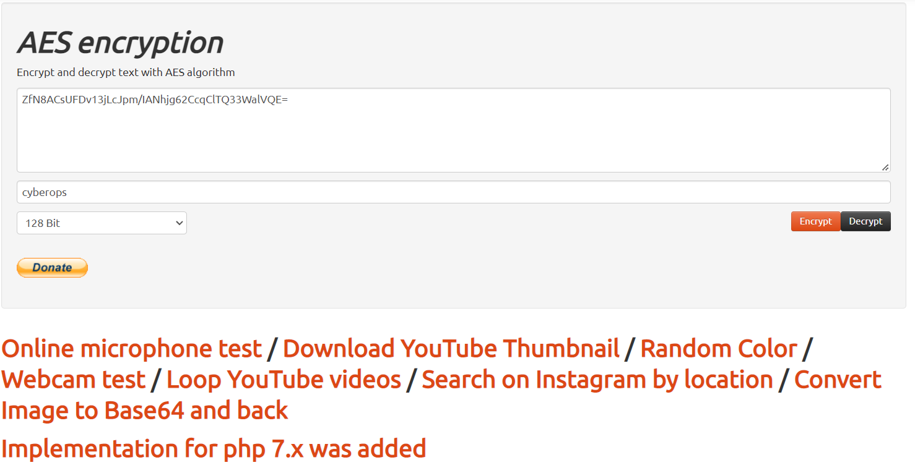

If I enter the wrong secret key, I can not decrypt the message.